******

**Fitting Manual**

|  |
| --- |
| iCLASS Handrail Safety Belt |

The iCLASS FP has Handrail Safety Belts fitted as standard.

**The lift will not operate without it.**

The Handrail Safety Belt is optional but **RECOMMENDED**

for the iCLASS P and SP

|  |  |  |
| --- | --- | --- |
| Description | | Quantity |
| C1A | Safety Belt Retractor | 1 |
| C1B | Safety Belt Buckle | 1 |
| B1B2C | Fitting Plates, Left and Right | 1 Set |
| C1D | 7/16” UNF x ¾” Screw | 2 |
| C1E | 7/16” Washer | 2 |
| C1F | 7/16” Nyloc Nut | 2 |
| B3G | M8 x 50mm Dome Hex Screw | 4 |
| B4H | M8 Washer | 8 |
| B5J | M8 Nyloc Nut | 4 |
| D1K | Safety Belt Wiring Harness\* | 1 |
| B6L | Grommet | 2 |

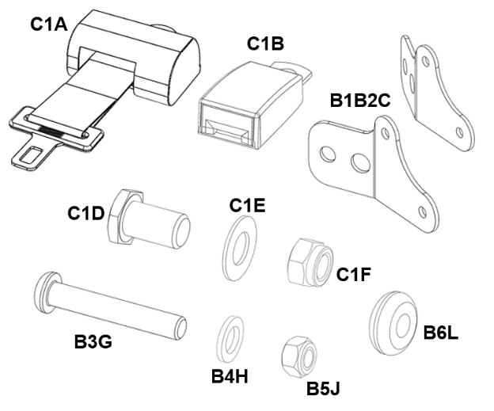

|  |  |
| --- | --- |
| ATT_warning | **WARNING** |
| These instructions are for the exclusive use of appropriately trained technical personnel. | |
| **Tools Required:**  Tools Required: 3, 5mm Hex (Allen) wrenches, 13mm Combination Wrench, 2 x 18mm combination wrenches, side cutters (optional).  **Other Equipment:** Handrail Safety Belt Kit, Zip-ties (optional). Mobility Networks Smart Lift App. | |
| **Refer to the exploded diagrams on the back page** | |
| **IMPORTANT NOTE:** The **Safety Belt Buckle** is fitted to the same side as the **Power Pack**. These instructions show the layout with the Power Pack fitted to the **RIGHT-HAND** side of the lift.  If the Power Pack is fitted to the LEFT-HAND side of the lift then fit the Buckle and wiring harness to the LEFT handrail. | |
| * DEPLOY and lower lift to working height * On the handle flange, removecover plate (Quantity 2 M5 x 10mm dome hex screws) (with 3mm Hex (Allen) key, see Figures 1 and 2. * Fit the grommets to the handrail(large) and the bracket(small). | |
|  |  |
| Above: Figure 1 cover plate in situ | Above: Figure 2 cover plate removed |

|  |  |
| --- | --- |
| * Thread the Safety Belt and Handrail Switch Wiring Harness into the hole on the Handrail, see Figure 3 until the plug exits at the handle flange. * Leave the connector for the buckle outside. | |
|  |  |
| Above: Figure 3 Handrail Cable Entry | Above: Figure 4 Shown with Buckle fitted |
| * Fit the brackets to the arms with the M8 fasteners (from Outboard in the order Screw, Washer, Fitting Plate, Handrail, Washer, Nut). | |
| * Fit the buckle to the bracket with the 7/16”NUF fasteners (from Outboard in the order Screw, Buckle (Retractor\*), Fitting Plate, Washer, Nut). * See Figure 4 showing right-hand side bracket / buckle assembly. | |
| * Connect the buckle to the Safety Belt Wiring Harness. Push the connector and slack cable into the handrail, Figure 4. | |
| * At the other end of the handrail, thread the other end of the wiring harness into the arm. Make sure the path for the cable is clear and that it won’t snag on any part of the knuckle mechanism. * Connect it to the plug in the arm. | |
| * Reversing the earlier step, on the handle flange, replace the cover plate making sure the cable doesn’t get trapped. | |
| * Taking care to make sure the new cable and connections don’t get trapped, STOW the lift. | |
| * DEPLOY and lower the lift to working height then, if necessary, carefully position and tighten zip-ties to tidy any excess cables inside the arm. | |
| * On the other handle, attach the retractor to the handle using the same method as the buckle\*. | |
| * Tighten all fasteners to the required torque. Fit Nut and Bolt Caps to the 7/16 fasteners. | |
| * Using the Mobility Networks Smart Lift APP: go to the Installer page. * On ‘Belt Interlock Status’ read then change the status from 0 to 1. * Reboot the lift. | |

